Trajectories of charged particles in Earth's magnetic field

Ali Qeble

*Sharif university of technology, Physics faculty*

1. INTRODUCTION

Ions and electrons trapped in the Earth’s magnetic field may affect our technology and our daily lives in significant ways. Energetic plasma particles may penetrate satellites and disable them temporarily or permanently. They can also pose serious health hazards for astronauts in space. Spectacles like the aurora are created by particles that enter the Earth’s atmosphere at polar regions; on the other hand, aircraft personnel and frequent flyers may accumulate a significant dose of radiation due to the same particles. The solar winds are a good example of a place in which these particles exist.

This paper aims to outline the graph of the trajectory for one of these charged particles by considering the relativistic motion.

Figure 1 shows a schematic description of the Earth’s magnetosphere, which is the region in space where the magnetic field of the Earth is dominant. Charged particles trapped in the magnetosphere, form the radiation belts, the plasmasphere, and current systems such as the ring current, tail current, and field-aligned currents. The Earth radius Re (6378.137 km) is a natural length scale for the magnetosphere. Near the Earth, up to 3-4Re, the field can be very well approximated with the field of a dipole. **

*FIG1: A schematic view of the Earth’s magnetosphere*

However, at larger distances, the effects of the solar wind cause significant deviations from the dipole.

The solar wind is a stream of charged particles released from the upper atmosphere of the Sun, called the corona. This plasma mostly consists of electrons, protons and alpha particles with kinetic energy between 0.5 and 10 keV.

1. PARTICLE TRAJECTORY IN DIPOLAR MAGNETIC FIELD

The motion of a particle with charge q and mass m in an electric field E and magnetic field B is described by the Newton-Lorentz equation:

$$γm \frac{dv}{dt}=qE\left(r\right)+qv ×B(r)$$

Here $γ= \frac{1}{√(1-\frac{v^{2}}{c^{2}})}$ is the relativistic factor and v is the particle speed. Considering the electric field in 2 ways, the First one is E=0, by this consideration the particle acceleration will be perpendicular to its velocity, the other perspective is:

E=E⊥ + E||

E|| is parallel to the magnetic field and removed because of the cross product, while E⊥ is perpendicular to the magnetic field which makes a constant velocity despite the particle mass:

$$V_{E}=\frac{E⊥ ×B}{{|B|}^{2}}$$

in this paper, we set E=0 and somehow, we neglect the electric field effect.

Now we consider motion under the influence of a magnetic dipole. The field $B_{dip}$ (r) of a magnetic dipole with moment vector M at location r is given byd

$$B_{dip}\left(r\right)=\frac{μ_{0 }}{4π r^{3}} [4\left(M.\hat{r}\right)\hat{r}-M]$$

where r = x $\hat{x}$ + y $\hat{y}$ + z $\hat{z}$, r = || For Earth, we take M = −*M $\hat{z}$* , antiparallel to the z-axis, because the magnetic north pole is near the geographic south pole. At the magnetic equator (x = 1Re, y = z = 0) the field strength is measured to be $B_{0} = 3.07 × {10}^{-5}T$. Substitution shows that $\frac{μ_{0}M }{π}= B_{0}{R_{e}}^{3}$. Then in Cartesian coordinates, the field is given by:

$$B_{dip}=-\frac{B_{0}{R_{e}}^{3}}{r^{5}}[3xz \hat{x}+3yz \hat{y}+\left(2z^{2}-x^{2}-y^{2}\right)\hat{z} ]$$

Figure 2 shows the trajectory of a proton from 100000 km in each axis from Earth, which is moving with 100km/s towards Earth in a limit time.

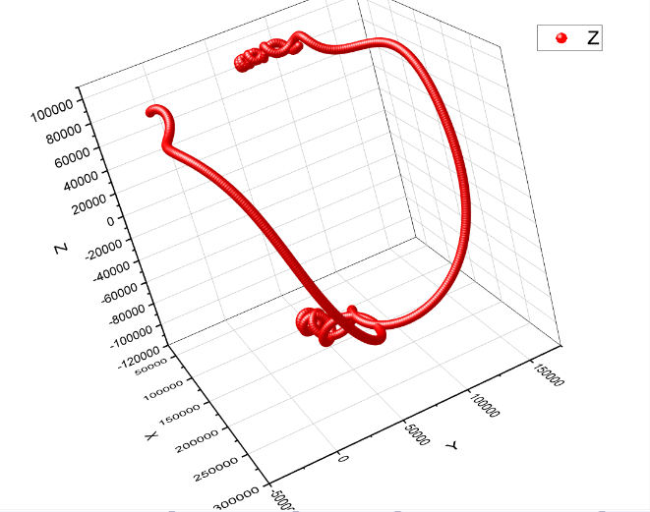

*FIG2: Trajectory of one proton in a limit time*

*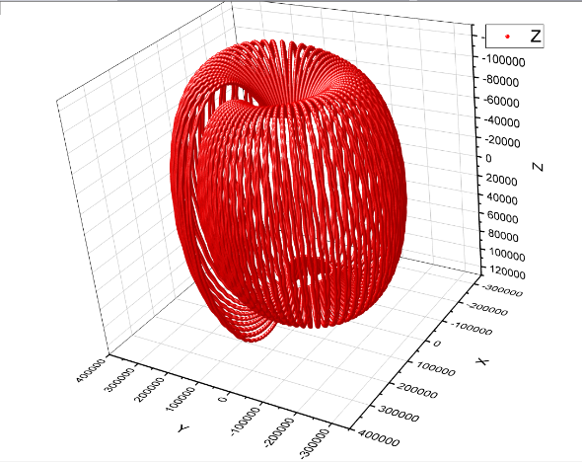FIG3: Trajectory of one proton in one loop*

The trajectory is calculated with a program code with c++ language and the data turns into a graph with origin application.

1. EXPLAINING THE TRAJECTORY

As we can see above in fig 2,3, there are three remarkable motions to take into account, in each axis. These are:

1. oscillating in z-axis
2. reflection of charged particle
3. circular motion

We can describe each of these motions with the concept of adiabatic invariants. If the parameters of an oscillating system are varied very slowly compared to the frequency of oscillations, the system possesses an adiabatic invariant, a quantity that remains approximately constant.

The concept of adiabatic invariance is introduced by considering the action integrals of a mechanical system. If qi and pi are the generalized canonical coordinates and momenta, then, for each coordinate which is periodic the action integral Ji is defined by:

$$J_{i}= \oint{p_{i}dq_{i}}$$

At last, by using the equation above we can find the adiabatic invariants and explain the motion of the charged particle.

1. REFERENCES
2. Trajectories of charged particles trapped in Earth's magnetic field, Article in American Journal of Physics, December 2011
3. All constants are derivate from NASA website, https://www.nasa.gov/
4. Classical Electrodynamics 3rd edition, John David Jackson